**Aaron Williams**

**Assignment 5**

**08 July 2017**

**Problem 1:**

Create a new vector class in C++ that has a constructor that initializes its instances to (0, 0, 0).

Output:



**Problem 2:**

Add a set Components function that will mutate (modify) the vector instance and

set its components to the three parameters x, y, z passed to the function,

respectively.

Output:



**Problem 3:**

Add a display function that displays the vector as (x, y, z).

Output:



**Problem 4:**

Overload the + symbol to become vector addition.

Output:

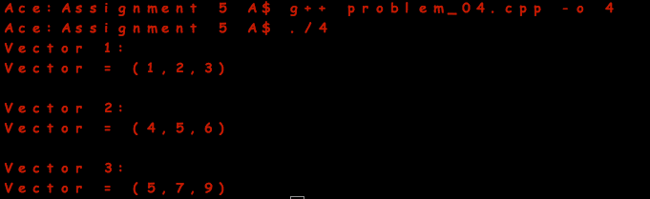

**Problem 5:**

Write a function called length() that returns the length of the vector as given by the formula:



meaning that the length is the square root of the sum of the components squared.

Output:

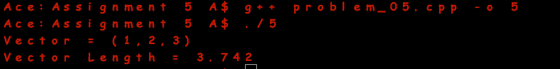

**Problem 6:**

Overload the rational == to yield true if v and w has the same length.

Output:

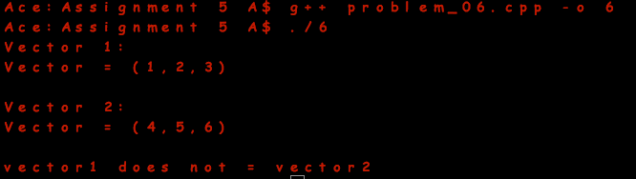

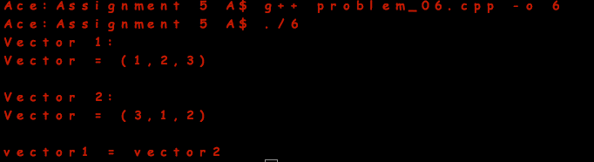

**Problem 7:**

Write a main function that creates two instances and correctly adds them, displays all three vectors, and the length of each vector.

Output:

